Specific Design Details

Ocean’s 7

Hassan Alahmed, Abby Caballero, Kyle Harlow,

Daniel Henderson, Yuvin Kokuhennadige, Cassandra Noice

27 October 2016

# Power Boards

One of the three main subsystems in Ocean’s 7’s product is the power board for the Robosub vehicle. This pcb will take in 14.8V power from the merge circuit board and convert it to various voltage levels to power each of the other systems on the vehicle. Additionally, the power board will contain a microcontroller to use for voltage and current sensing as well as a mechanical kill switch. As such, this subsystem will be a pcb containing the following:

* 3.3V buck conversion circuit using Recom R-78E3.3-1.0 Switching Regulator
* 5V buck conversion circuit using Recom R-78E3.3-1.0 Switching Regulator
* 12V conversion circuit using LTC3780 High Efficiency, Switching Boost Converter
* 19V conversion circuit using LTC3780 High Efficiency, Switching Boost Converter
* 48V conversion circuit using LTC3780 High Efficiency, Switching Boost Converter
* Board-to-Board connector (either Molex or other slot connector)
* MK20DX256 ARM microcontroller connected to the power conversion circuits to monitor voltages and currents
* Infineon OptiMOSTM Power-MOSFET for the kill switch

# Backplane

The second subsystem in the Ocean’s 7 project is the backplane. This is a board used to route all communications and power traces throughout the hull of the Robosub vehicle. It will be in two parts: a center section, and an auxiliary sections. The center section will lie near the center of the hull and it will contain the current merge circuit as well as normal backplane traces. The auxiliary section will contain only the backplane traces and board connectors. The two sections will be connected via board-to-board connectors and ribbon cables. To this end, this subsystem will be:

* Center Board
  + Backplane traces
    - 3.3V, 5V, 12V, 14.8V, 19V, 48V
    - I2C communications traces
    - RS232 communications traces
  + Current Merge Circuit
    - LTC4357 Positive High Voltage Diode Controller
    - Inputs from 2 Lithium Polymer batteries
    - Below is a schematic of the merge circuit as implemented on the Ocean’s 7 babyboard assignment. The circuit works exactly as described, sharing the load of the board between the 2 batteries.
  + Wire-to-board connectors
    - 8x Motors: 4-pin, 30A  
      10 AWG, .250" PowerStrip™/40 A Single Row Discrete Wire Cable Assembly (Samtec)
    - 2x Batteries: 4-pin, 100A  
      8 AWG, Mini-Fit Sr.™ Power Wire-to-Board Connectors (Molex)
    - Control system: x-pin, 3A  
      CLIK-Mate™ Wire-to-Board Connectors (Molex)
    - Hydrophones: 4-pin, 1A, data
    - Kill Switch: 3-pin, 0.1A
* Auxiliary board
  + Same as above, sans merge circuit

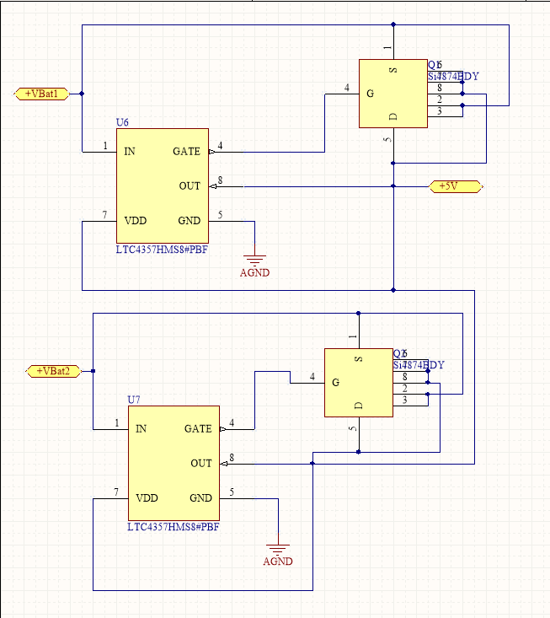

***(Current Merge Circuit Schematic, from the babyboard)***

Below is a list of risks and our contingency plan for the power and backplane:

|  |  |
| --- | --- |
| Risks | Contingency Plan |
| Excessive heating from the 200A trace | Minimize trace length from the current merge circuit to the ESCs |
| Power traces interrupting data traces | Proper trace isolations |
| Trace failure (due to heating, soldering, etc.) | Liquid electrical tape |
| Hole flooding due to a leak in the hull | Use mineral oil to fill the hull |

Additionally included is the Bill of Materials for the Power and Backplane subsystems.

|  |  |  |  |
| --- | --- | --- | --- |
| **Item** | **Price ($)** | **Quantity** | **Subtotal ($)** |
| 2-layer PCB | 33 | 3 (x3 revisions) | 297 |
| Power MOSFETs | 6 | 12 | 76 |
| MK20DX microcontroller | 5 | 3 | 15 |
| DC/DC converters | 6 | 12 | 72 |
| LiPo batteries | 100 | 6 | – |
| Misc Parts (ICs, resistors, capacitors, connectors) | - | - | 160 |
| Shipping | 100 | - | 100 |

TOTAL = **$ 720**

# Controls System

Finally, the controls system is one of the most crucial subsystems in the Robosub vehicle. This will be a single pcb with a microcontroller, voltage regulator, I2C and RS232 communication traces, appropriate connector for attaching to the backplane, and a control signal output to each of the 8 Electronic Speed Controllers (ESC) on the sub. There will also be an ethernet connection to the DVL. Additionally, this board will require a JTAG programming interface to load code onto it. As such, the board will contain:

* STM32F767 ARM Cortex M7 microcontroller
  + openRTOS real-time operating system
  + PID controls algorithms, first modeled and tuned in Matlab and Simulink
  + H2/Hinf algorithms as time allows
  + Low-level drivers for communication and speed control
* Connector to the backplane
* Communication traces
* JTAG
* USB
* Ethernet
* 8 Board-to-wire connectors

Below is our list of risks and their respective contingency plans for the controls team:

|  |  |
| --- | --- |
| Risks | Contingency Plan |
| Possibility of mechanical team changing motor placement | Communication is key, but we would need to redesign controllers |
| Need actual robot in order to tune effectively, there is a possibility that we may not have the robot ready until much later | May need to design controller for old submarine system if new system will not be ready in time |
| Little knowledge about H2 and H∞ controllers, this will prove to be a challenging problem | This will require lots of time to learn and to get the math correct, but if it doesn’t work we will have our PID controller as a backup |
| Unable to purchase certain necessary sensors, we must not break the ones we already have | Send parts back to manufacturer for repair |
| Need to coordinate with other teams for integration, this usually causes unforeseen issues | Lots of communication and plan as much time as possible for integration |

Additionally included is the Bill of Materials for the controls system.

|  |  |  |  |
| --- | --- | --- | --- |
| **Item** | **Price ($)** | **Quantity** | **Subtotal ($)** |
| Microcontroller | 15 | 3 | 45 |
| STM32 Development Board | 50 | 1 | 50 |
| 2-layer PCB | 33 | 1 (x3 revisions) | 198 |
| Misc. Parts & Connectors | - | - | 30 |
| Shipping | 40 | - | 40 |

TOTAL = **$ 363**

# Budget

The budget for the Ocean’s 7 team is provided by the Robosub group at CU. They have already allocated $2000 for Ocean’s 7 expenses - we intend to use closer to $1200, as shown below.

|  |  |
| --- | --- |
| **Item** | **Subtotal ($)** |
| Power & Backplane Subsystems | 720 |
| Controls Subsystem | 363 |
| Misc. Parts & Connectors | 60 |

TOTAL = **$ 1143**

# Division of Labor

As a team, we divided out responsibilities and roles amongst our team members early on in the design process. These include administrative roles as well as specific technical responsibilities and areas of leadership. Given that as of now we are in the beginning of the actual technical design and implementation process (in terms of pcb schematics, control algorithms, etc.), we have not yet come into any major problems or challenges with our setup. Most of the documents we have created so far have all been collaborative, with no one person taking too much control over each. That being said, we did have some bottlenecks in terms of the product description/requirements, on account of the Robosub Liaison simply being the team member most qualified to speak with authority on those issues. As such we had some difficulties with a few of the documents, but now we are all on the same page and able to work independently on each of our tasks. Additionally, we have essentially built into the Robosub Liaison’s role the role of question-answerer for design questions that require Robosub experience.

|  |  |
| --- | --- |
| **Kyle (Power and Controls)** | Project Co-Lead, Robosub Liaison, Design Point Person, Merge Circuit Board Design |
| **Cassandra (Controls)** | Project Co-Lead, Chief Administrator, Controls Board Design, Controls Algorithms |
| **Abby (Controls)** | Controls Board Design, Controls Algorithms, Motor SysID |
| **Daniel (Controls)** | Budgeteer, Controls Board Design, Controller Software, Manage Ordering Materials for Controls |
| **Hasan (Power)** | Backplane Design, Order Power PCBs |
| **Yuvin (Power)** | Converter Board Design, Manage Ordering Power Parts |